The Open Source Audit
A Capstone Project Report

on

Apache HTTP Server

Submitted by:
Dev Wandalkar
Reg No: 24BCE10822

Course: Open Source Software
Slot: A11
Date of Submission:
Mar 31, 2026

1. Origin and Philosophy
1.1 The Problem Apache HTTP Server Was Created to Solve
In the early 90s, the web was only beginning to take shape. Most websites depended on a program called NCSA HTTPd, which was quite ground-breaking at that time. However, even with its widespread use, it could not handle every need properly. Over time, updates started slowing down and eventually development stopped completely. This put users in a difficult situation. Without regular bug fixes, issues began stacking up bit by bit. New features were no longer expected. Support was almost non-existent right when people needed it the most. As internet usage increased, the gap between what the software delivered and what users demanded kept growing larger.
At the same time, web usage started expanding quickly and many groups wanted their own presence online. But they faced problems like slow performance, fixed configurations, and limited flexibility. The code was available but rarely improved, so developers began creating their own custom fixes to solve issues and add new features. These modifications spread in different directions without coordination, leading to confusion instead of consistency. Maintaining stability became difficult when each version started drifting on its own path.
Then, a group led by Brian Behlendorf came together as the number of fixes kept increasing. Their combined effort brought those scattered changes into a single, more reliable web server. This project eventually became known as the Apache HTTP Server. Some believe the name Apache was inspired by how it originally looked, full of patches loosely put together like stitched pieces of cloth.
The decision to make Apache open source instead of keeping it restricted was driven by a clear idea. The team believed the web should remain open and not be controlled by a single company. By making the code accessible, anyone could use it, modify it, and improve it. This openness allowed fixes and improvements to grow quickly through shared effort. Over time, stability improved, security became stronger, and features expanded beyond what earlier systems could offer.
Created out of necessity, Apache filled the gap at a time when reliable web servers were hard to find during the rapid growth of the internet. What started as scattered patches turned into something much more powerful, a collaborative project that helped shape the foundation of the modern web.
1.2 The License - What It Actually Says
The Apache HTTP Server is released under the Apache License 2.0, which is a permissive open-source license. This license allows users a high degree of freedom while still maintaining certain legal protections for the original developers.
The Four Freedoms of Free Software
The idea of free software is based on four essential freedoms:
- Freedom 0: The freedom to run the program for any purpose without restrictions.
- Freedom 1: The freedom to study how the program works and modify it according to individual needs. This requires access to the source code.
- Freedom 2: The freedom to redistribute copies of the software to others.
- Freedom 3: The freedom to distribute modified versions so that improvements can benefit the community.
Apart from offering basic functionality, this server grants full rights to examine how it works. Modification is allowed once someone obtains the code, meaning changes can be made without restriction. Sharing happens openly - both unchanged copies and altered forms circulate freely among users.
Commercial Use and Changes Allowed
Commercial use stands permitted under the Apache License. Should a business choose, it may adopt the Apache HTTP Server, alter its code, then distribute the result within a proprietary offering. Profit-driven deployment does not violate terms.
Still, specific requirements apply
- The original license must be included
- Recognition should go to those who first created it
- The modified version must clearly indicate changes
Freed from public disclosure rules, firms can tweak the source without sharing changes - this freedom draws many toward the license.
Difference Between Apache License and GPL
The Apache License differs sharply from the GNU General Public License, though both are frequently mentioned together. One builds on permissive principles, whereas the other enforces strict sharing rules. Their core ideas pull in separate directions; flexibility here, control there. Each reflects a distinct view of software freedom.
- The Apache License is permissive. It allows modifications and commercial use without forcing users to share their changes.
- The GPL is a copyleft license. It requires that any modified version of the software must also be distributed as open source under the same license.
Choosing a license for my project, I’d lean toward Apache. It allows greater freedom while supporting community work alongside business use. Flexibility stands out here, opening doors without demanding strict reciprocity. That balance makes it stand apart from others in practice.
Free as in Cost vs Free as in Freedom
In open-source discussions, “free” does not only mean free of cost. There are two meanings:
- Free as in free beer: The software is available at no cost
- Free as in freedom: Users have the freedom to use, modify, and distribute the software
Apache HTTP Server represents both meanings. It is free to download and use, but more importantly, it gives users the freedom to customize and improve it according to their needs.
1.3 The Ethics of Open Source
Open source is not just a technical model of software development; it represents a broader philosophy about how knowledge and technology should be shared. It raises important ethical questions about ownership, collaboration, and fairness in the digital world.
Should all software be open source?
One might argue that opening up all software code could foster greater collaboration. Yet others believe keeping some programs closed protects innovation. Sharing everything freely may encourage transparency. Still, restricting access at times can support sustainable development. Some see openness as a path to equality. Others warn it risks undermining creators’ efforts. Making every program available sounds ideal on the surface. In practice, though, balance matters more than absolutes.
Open source fuels openness, skill growth, and fresh ideas. Because the code sits out in the open, coders get a chance to see behind the scenes, tweak what exists, then craft something different using prior work as foundation. Efforts aren’t wasted reinventing tools already built; instead, advancement moves faster. With eyes everywhere, flaws or sneaky functions are more likely to be spotted, which builds stronger confidence over time.
Still, opening every kind of software isn’t always practical. Firms spend large amounts of effort, funds, and energy building closed programs, counting on them to bring income. Without the chance to earn back those costs, fewer might take risks creating new tools in specific areas. Meanwhile, particular applications handle confidential information or pose safety issues, exposing them completely could create serious problems.
Looking at it one way, open source deserves support in most situations. Yet room remains for private software when circumstances or goals make it more suitable
Is it ethical for companies to profit from open-source software?
This issue still sparks discussion within the open source community. While many companies make profits, they often rely heavily on tools like Linux and Apache.
At the same time, this approach remains ethically valid, since open source licenses such as the Apache License clearly permit commercial usage. Even then, many organizations contribute in return by fixing errors, enhancing performance, or offering financial support. These contributions help keep the system fair and cooperative for all participants.
However, there are still concerns that some companies might benefit from shared resources without giving enough back. When businesses earn large profits using open source software but fail to share improvements or assist the developers, it starts to seem unfair. Ultimately, fairness depends on maintaining a balance between what is taken and what is returned. Ethical practice is shown not just in using resources, but also in contributing back.
“Standing on the shoulders of giants”
What we call progress often begins by using knowledge left behind by those who came before. Open-source thrives when people take earlier efforts and shape them into something fresh. Earlier breakthroughs become tools, not endpoints. One person's solution opens paths someone else walks later. Ideas pass forward, shift slightly, grow stronger. This sharing turns isolated advances into shared momentum.
Because code is shared openly, creators can build directly on what others made. Starting from scratch becomes rare when proven pieces are freely available. Innovation moves faster since effort shifts toward fresh challenges. Complex tools reach wider audiences without gatekeeping. Progress grows not by isolation, but through reuse and collaboration.
Still, a few worry that leaning hard on current open-source options can dull creativity. Rather than grasp core ideas fully, coders could lean on ready-made components. Even so, in most cases, shared code removes barriers by fueling new thinking more than holding it back.
2. Linux Footprint
Installation Method
Apache HTTP Server was installed using the apt package manager on Kali Linux. This method simplifies installation by automatically resolving dependencies and configuring the software.
sudo apt update
sudo apt install apache2

Key Directories
From the system analysis, Apache is distributed across standard Linux directories:
- Binary location: /usr/sbin/apache2, found using which command
- Configuration directory: /etc/apache2
- Log directory: /var/log/apache2
The /etc/apache2 directory contains important configuration files such as: apache2.conf, ports.conf, sites-available and sites-enabled etc.
The /var/log/apache2 directory contains log files including: access.log, error.log and other_vhosts_access.log
These logs help in monitoring server activity and debugging issues.
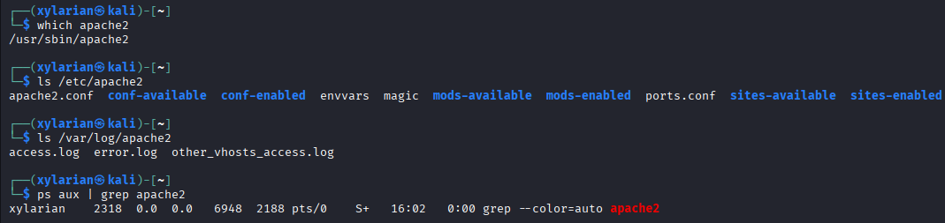
User and Group
Apache HTTP Server follows a privilege separation model for better security. From the process analysis, it is observed that the main (parent) process runs under the root user, while multiple worker processes run under the www-data user and group.
- Parent Process: root
- Worker Processes: www-data
This design ensures that while the server can start with necessary system privileges, the actual handling of client requests is done by a less-privileged user. As a result, even if a vulnerability is exploited, the impact is limited and does not compromise the entire system.
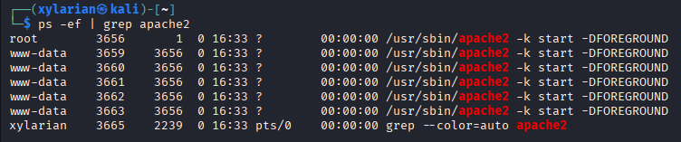
Service Management
Apache runs as a system service managed through systemctl. The following commands were used:
sudo systemctl start apache2
sudo systemctl stop apache2
sudo systemctl restart apache2
sudo systemctl status apache2

The service status output showed:
- Active state: running
- Main PID: active process handling requests
- Status message: processing requests
This confirms that Apache is functioning correctly and handling web requests.
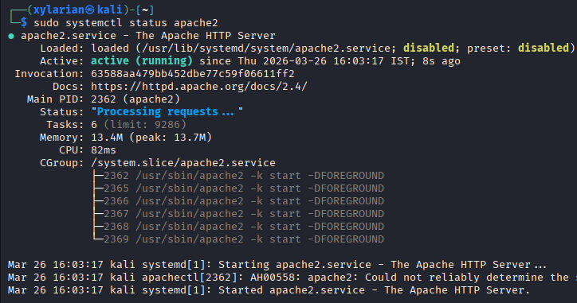
Update Model
Apache updates are handled through the package manager:

sudo apt update
sudo apt upgrade apache2

Security patches and updates are released by the open-source community and distributed via repositories. This ensures that the system remains secure and up to date with minimal effort.
3. The FOSS Ecosystem Around Apache HTTP Server
Dependencies and Supporting Tools
Apart from core modules, Apache HTTP Server uses multiple open-source tools to operate effectively
- APR (Apache Portable Runtime): Provides a consistent interface to underlying OS features like file handling and networking.
- APR-Util: Extends APR with additional utilities such as database access and XML parsing.
- OpenSSL: Enables secure communication through HTTPS by providing SSL/TLS encryption.
- PCRE (Perl Compatible Regular Expressions): Used for pattern matching in configuration and URL rewriting.
These dependencies allow Apache to remain portable, secure, and highly customizable across different operating systems.
What Apache Has Enabled or Inspired
Since its early development, Apache played a major role in shaping how modern websites function; because of it, many software solutions came into existence. Even though it often stays behind the scenes, its impact spreads widely across internet infrastructure. Wherever online services operate, elements of this platform are usually present. Its code served as a base that others quietly built upon over time. As the internet expanded, dependence on what started as a simple project also continued to grow
• The system acted as the main backbone for early web hosting environments.
• This influence also pushed other projects like Nginx to rethink performance under heavy load. Increasing demand became a driving force, changing how such systems manage high traffic.
• A large number of websites created using platforms like WordPress rely on Apache to serve content. However, some prefer alternatives depending on their requirements. Even so, Apache continues to be widely used across different systems. While speed plays a role, compatibility is often the deciding factor. Even modern setups still use it despite other available options.
• Through its modular design, it allows developers to add features like authentication, caching, or scripting support. As it grows, the system integrates these additions smoothly using flexible modules.
Driven by its flexibility, Apache has become a key part of many web platforms. Even as an open system, it supports a large portion of internet infrastructure. Wherever customization is important, this software often supports digital systems. Because it remains freely accessible, developers continue to depend on it. Its structure allows easy modification, adapting quietly to different needs.

Role in the LAMP Stack
Apache is a core component of the LAMP stack, which includes:
- Linux (Operating System)
- Apache (Web Server)
- MySQL (Database)
- PHP (Server-side scripting language)
In this stack, Web traffic flows through Apache first, since it serves as the main receiver of HTTP requests while sending back website data. This setup links user browsers to deeper layers such as databases or processing scripts. Its role sits at the core of how web apps are built and function.
Community and Governance
Apache HTTP Server is maintained by the Apache Software Foundation (ASF), a non-profit organization that supports many open-source projects.
The Apache community is large and active, and it includes:
- Mailing lists for developers and users
- Online forums and documentation
- IRC channels and discussion platforms
- Conferences and events related to open source
The governance model is community-driven, meaning decisions are made collaboratively by contributors rather than controlled by a single company. This ensures transparency, continuous improvement, and long-term sustainability of the project.
4. Open Source vs Proprietary (Critical Analysis)
Dimension | Apache HTTP Server (Open Source) | Microsoft IIS (Proprietary)
Cost | Free to use, modify, and distribute | Requires Windows Server license (paid)
Security | Source code is open for public auditing; vulnerabilities can be identified and fixed by the community | Source code is closed; users must rely on Microsoft for security updates
Support & Reliability | Community support via forums, documentation, and contributors; reliable but may require self-troubleshooting | Official support from Microsoft with dedicated services and documentation
Freedom to Modify | Full freedom to modify source code and customize behavior | Limited customization; no access to source code
Community vs Control | Community-driven development under Apache Software Foundation | Fully controlled and developed by Microsoft
Overall Verdict | Best suited for flexibility, cost-effectiveness, and open environments | Better suited for enterprise Windows-based ecosystems with official support

Based on the findings of this study, selecting Apache HTTP Server seems like a practical choice when building systems where openness, affordability, and flexibility are priorities. Since it is open source, teams can adjust its functionality to meet specific needs, something fixed platforms often struggle to provide. Improvements continue steadily because active contributors keep resolving issues and introducing new features. The ability to review the entire codebase also supports better security checks, which gradually builds trust. Although the setup process may require more effort compared to closed systems, having complete control over its behavior proves valuable across different applications. What makes it stand out is not only its performance but also how well it fits into changing infrastructures over time.
In the future, I would like to contribute to Apache HTTP Server. Being part of something meaningful could improve my understanding of complex systems while also helping enhance the tool for others. Learning becomes more effective when knowledge is shared among people, especially those with experience. Community driven projects reflect a strong idea that progress grows when effort is shared instead of kept limited. In the end, what truly lasts is collective work, not just the code itself.

Shell Script Tasks
Script 1 — System Identity Report
Script Code:
#!/bin/bash
# ==========================================================
# Script 1: System Identity Report
# Author: Dev Wandalkar
# Course: Open Source Software
# Description: Displays important system information
# ==========================================================
# ----------- User-defined Variables ------------------------
STUDENT_NAME="Dev Wandalkar " # Stores student name
SOFTWARE_CHOICE="Apache HTTP Server" # Stores chosen software
# ----------- System Information Collection -----------------
# Get Linux kernel version
KERNEL=$(uname -r)
# Get current logged-in user
USER_NAME=$(whoami)
# Get system uptime in readable format
UPTIME=$(uptime -p)
# Get current date and time
DATE=$(date)
# Get Linux distribution name from OS release file
DISTRO=$(grep PRETTY_NAME /etc/os-release | cut -d= -f2 | tr -d '"')
# ----------- Display Output -------------------------------
echo "========================================"
echo " Open Source Audit — $STUDENT_NAME"
echo "========================================"
echo "Software Chosen : $SOFTWARE_CHOICE"
echo "Distribution : $DISTRO"
echo "Kernel Version : $KERNEL"
echo "Current User : $USER_NAME"
echo "Home Directory : $HOME"
echo "Uptime : $UPTIME"
echo "Date & Time : $DATE"
echo ""
# Display license information
echo "License Info : Linux is typically licensed under the GNU General Public License (GPL)."
echo "========================================"
Screenshot of it running:
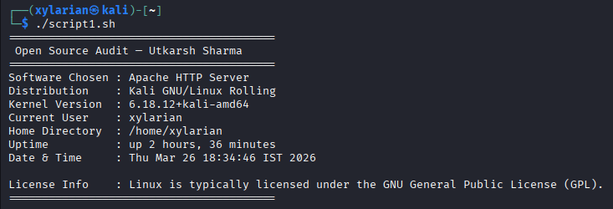
What you see here is a small program creating a summary of system traits on Linux machines. Grabbing data happens through stored values combined with outputs from terminal tools. Kernel release shows up by running uname -r, while whoami reveals the active account. System runtime appears using uptime -p; current timestamp comes straight from date. Distribution name pulls out lines from /etc/os-release, filtering what matters. Text layout gets shaped via echo, arranging pieces into readable blocks. Learning how scripts handle dynamic inputs becomes clear through these steps. Variables hold snippets, command substitution injects real-time results, formatting keeps it clean.
Script 2 — FOSS Package Inspector (Apache-focused)
Script code:
#!/bin/bash
# ==========================================================
# Script 2: FOSS Package Inspector
# Author: Dev Wandalkar
# Course: Open Source Software
# Description: Checks if a package is installed and displays info
# ==========================================================
# ----------- Variable --------------------------------------
PACKAGE="apache2" # Package name (Apache HTTP Server)
# ----------- Check Installation ----------------------------
# Check if package is installed using dpkg
if dpkg -l | grep -qw $PACKAGE; then
echo "$PACKAGE is installed on this system."
# Display package details (Version, License, Description)
echo ""
echo "Package Information:"
dpkg -l $PACKAGE | grep $PACKAGE
else
echo "$PACKAGE is NOT installed on this system."
fi
# ----------- Case Statement (Philosophy Notes) -------------
echo ""
echo "Philosophy Note:"
case $PACKAGE in
apache2)
echo "Apache: Backbone of the open web, enabling free and open access to information."
;;
mysql)
echo "MySQL: Open source database powering millions of applications."
;;
vlc)
echo "VLC: Media freedom — play anything without restrictions."
;;
firefox)
echo "Firefox: A browser built to keep the web open and user-focused."
;;
*)
echo "Unknown package — open source promotes collaboration and freedom."
;;
esac
Screenshot of it running:
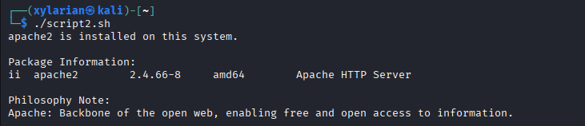
This script checks whether a specified open-source package is installed on the system. It uses an if-else condition along with dpkg -l and grep to verify the presence of the package. If installed, it displays basic package information. A case statement is then used to print a short philosophy note related to the package, demonstrating conditional branching. The script highlights how Linux tools can be used to inspect software and connect technical details with open-source concepts.
Script 3 — Disk and Permission Auditor
Script code:
#!/bin/bash
# ==========================================================
# Script 3: Disk and Permission Auditor
# Author: Dev Wandalkar # Course: Open Source Software
# Description: Checks directory size, ownership, and permissions
# ==========================================================
# ----------- Directory List -------------------------------
DIRS=("/etc" "/var/log" "/home" "/usr/bin" "/tmp")
echo "========================================"
echo " Directory Audit Report"
echo "========================================"
# ----------- Loop Through Directories ---------------------
for DIR in "${DIRS[@]}"; do
# Check if directory exists
if [ -d "$DIR" ]; then
# Get permissions, owner, group
PERMS=$(ls -ld $DIR | awk '{print $1, $3, $4}')
# Get size of directory
SIZE=$(du -sh $DIR 2>/dev/null | cut -f1)
echo "$DIR => Permissions: $PERMS | Size: $SIZE"
else
echo "$DIR does not exist on this system"
fi
done
# ----------- Apache Config Directory Check ----------------
echo ""
echo "Apache Configuration Directory Check:"
CONFIG_DIR="/etc/apache2"
if [ -d "$CONFIG_DIR" ]; then
PERMS=$(ls -ld $CONFIG_DIR | awk '{print $1, $3, $4}')
echo "$CONFIG_DIR exists => Permissions: $PERMS"
else
echo "$CONFIG_DIR does not exist"
fi
echo "========================================"
Screenshot of it running:
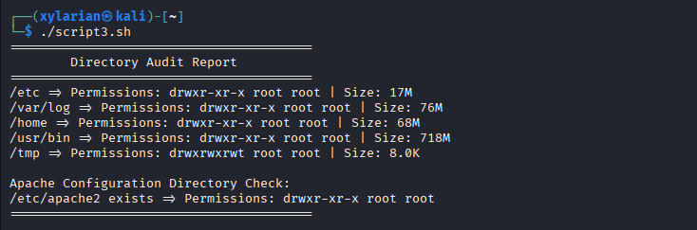
This script audits important system directories by checking their disk usage, ownership, and permissions. It uses a for loop to iterate through a predefined list of directories and verifies their existence using an if condition. The ls -ld command is used to extract permissions and ownership details, while du -sh calculates directory size. Additionally, the script checks the Apache configuration directory to demonstrate application-specific auditing. This script showcases the use of loops, conditional statements, and command-line tools for system analysis.

Script 4 — Log File Analyzer
Script Code:
#!/bin/bash
# ==========================================================
# Script 4: Log File Analyzer
# Author: Anushka
agarwal
# Course: Open Source Software
# Description: Counts keyword occurrences in a log file
# ==========================================================
# ----------- Input Arguments ------------------------------
LOGFILE=$1 # First argument → log file path
KEYWORD=${2:-"error"} # Second argument → keyword (default: error)
COUNT=0 # Counter for matches
# ----------- File Check -----------------------------------
# Check if file exists
if [ ! -f "$LOGFILE" ]; then
echo "Error: File $LOGFILE not found."
exit 1
fi
# ----------- Empty File Check (Retry Logic) ---------------
if [ ! -s "$LOGFILE" ]; then
echo "Warning: File is empty. Retrying in 2 seconds..."
sleep 2
if [ ! -s "$LOGFILE" ]; then
echo "File is still empty. Exiting."
exit 1
fi
fi
# ----------- Read File Line by Line -----------------------
while IFS= read -r LINE; do
# Check if line contains keyword (case-insensitive)
if echo "$LINE" | grep -iq "$KEYWORD"; then
COUNT=$((COUNT + 1))
fi
done < "$LOGFILE"
# ----------- Output Summary -------------------------------
echo "========================================"
echo "Log Analysis Report"
echo "========================================"
echo "File : $LOGFILE"
echo "Keyword : $KEYWORD"
echo "Occurrences: $COUNT"
# ----------- Show Last 5 Matching Lines -------------------
echo ""
echo "Last 5 matching lines:"
grep -i "$KEYWORD" "$LOGFILE" | tail -n 5
echo "========================================"
Screenshot of it running:
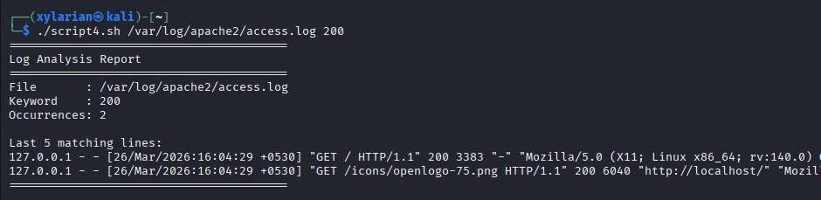
This script analyzes a log file by counting the number of occurrences of a specified keyword. It takes the log file path and keyword as command-line arguments. A while read loop is used to process the file line by line, and an if condition with grep checks for matches in a case-insensitive manner. A counter variable tracks the number of occurrences. The script also includes error handling for missing or empty files and displays the last five matching lines using grep and tail. This demonstrates file handling, loops, conditional logic, and argument passing in shell scripting.
Script 5 — Open Source Manifesto Generator
Script Code:
#!/bin/bash
# ==========================================================
# Script 5: Open Source Manifesto Generator
# Author: Dev Wandalkar
# Course: Open Source Software
# Description: Generates a personalized open-source manifesto
# ==========================================================
echo "========================================"
echo " Open Source Manifesto Generator"
echo "========================================"
echo ""
# ----------- User Input -----------------------------------
# Take input from user
read -p "1. Name one open-source tool you use every day: " TOOL
read -p "2. In one word, what does 'freedom' mean to you? " FREEDOM
read -p "3. Name one thing you would build and share freely: " BUILD
# ----------- System Info ----------------------------------
DATE=$(date '+%d %B %Y') # Current date
USER_NAME=$(whoami) # Current user
OUTPUT="manifesto_$USER_NAME.txt" # Output file name
# ----------- Generate Manifesto ---------------------------
echo "Generating your manifesto..."
echo ""
echo "On $DATE, I, $USER_NAME, reflect on the power of open source. Tools like $TOOL represent not just software, but a vision of $FREEDOM. I believe in building and sharing knowledge, and one day I aim to create $BUILD and contribute it freely to the community. Open source is not just about code, but about collaboration, transparency, and collective growth." > $OUTPUT
# ----------- Display Output -------------------------------
echo "Manifesto saved to $OUTPUT"
echo ""
echo "Your Manifesto:"
echo "----------------------------------------"
cat $OUTPUT
echo "----------------------------------------"
# ----------- Note on Alias (concept demonstration) --------
# Example alias (not executed):
# alias manifesto="cat $OUTPUT"
Screenshot of it running:
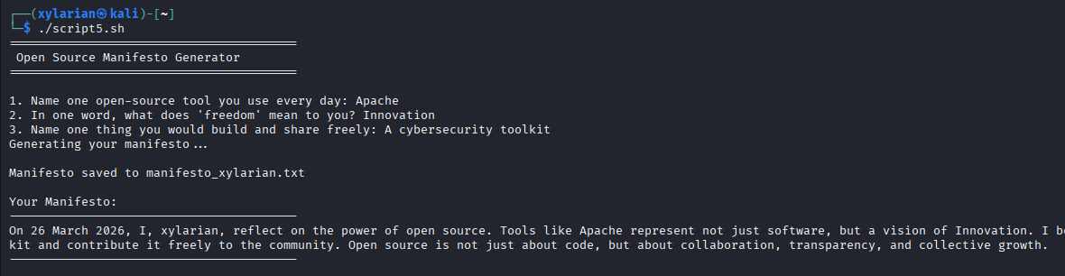
This script creates a customized open source manifesto by accepting user input through the read command. It gathers responses related to tools, freedom, and ideas, then merges them into a well-structured paragraph using string concatenation. The final result is written into a text file with the help of output redirection (>). The script also makes use of system commands like date and whom to add dynamic details. In addition, a sample alias is included in the comments to show how command shortcuts can be used. Overall, this script demonstrates user input handling, file operations, and dynamic content creation in shell scripting.
.

